PROGRAMME: BSSE/BSCS/BIT
YEAR/SEM: YEAR 2 SEM 1
COURSE CODE: COURSE CODE COMES HERE
PROBLEM NAME: COMPLETE NAME OF TASK

STUDENT DETAILS:
NAME OF STUDENT
REG NUMBER

Table of Contents

List of Figures
Figure 1:Class Main showing project structure 4

Section 1
Logic Building & Programming
Lines of code & explanations
Line Number | Explanation

Detailed Screenshots and caption descriptions
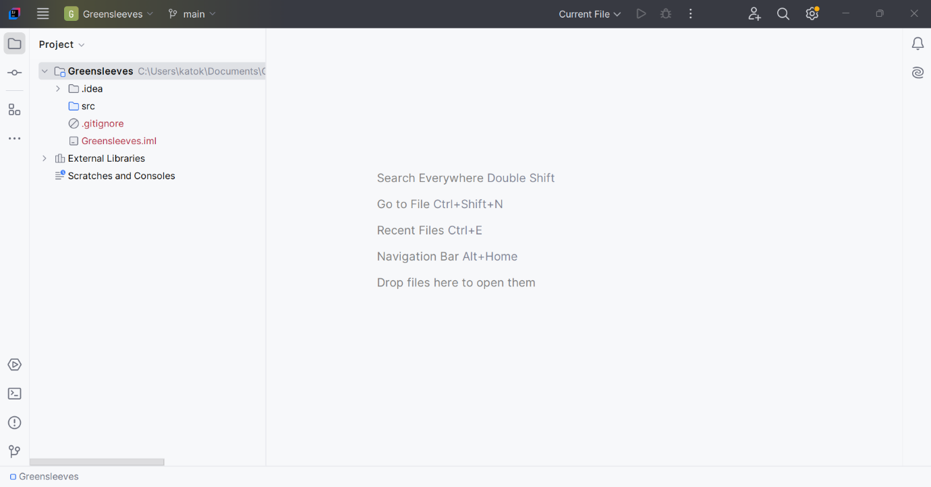
Figure 1:Class Main showing project structure

Output and caption descriptions
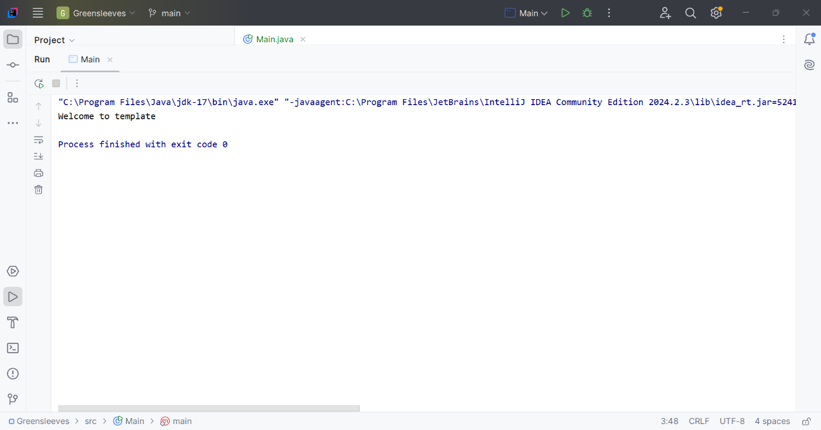
Figure 2: Output after running the program

Output Explanation
From the output provided above, when the program is executed, it will display the output as seen above.

Section 2
Version Control
Repository Overview
Repository Name
Repository URL
Branches

Commit #1 On Branch #1
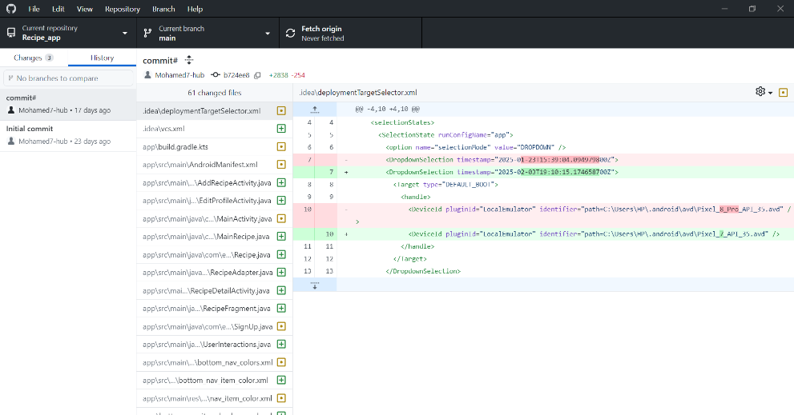
Figure 3: Commit 1 on Branch 1

Commit Summary
Commit Name
Commit ID
Commit Description
Branch Affected

Section 3
What Have You Learned From The Task?

Skill Set | Description

